# Kalyk Zhalgas , Kyndybaiuly Yerkuat Astana IT University IT-2001 Object-Oriented Programming (Java) Elvira Aitmukhambetova

# Link for github : <https://github.com/Sp0o0o0kY/EndtermProject>

# The main purpose if our code is getting information (first name , last name , position , salary) from clients and by this creating the table

# Classes :

# 1)Employee.java

# Interface – IemployeeRepositories.java

# 2)EmployeeController.java

# 3)EmloyeeRepositories.java

# 4)Main.java

# PostgreSQL connection – Data collection

# Interface – IDB.java

# PosgresDB.java

# C:\Users\Predator\AppData\Local\Microsoft\Windows\INetCache\Content.Word\photo5355184075167609374.jpg

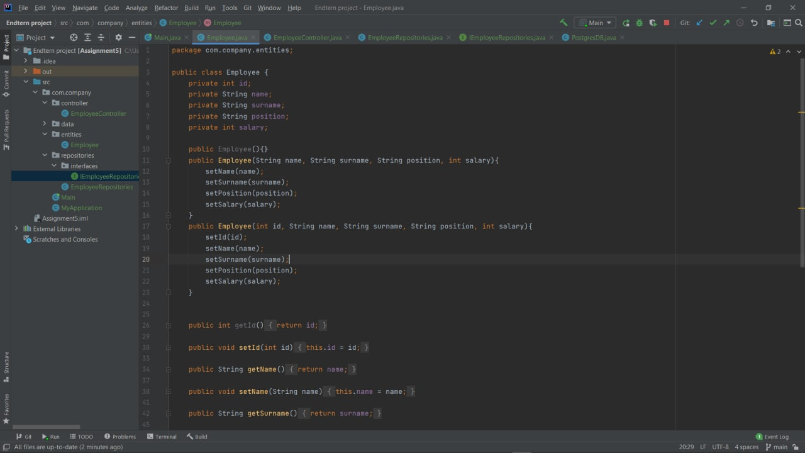

# C:\Users\Predator\AppData\Local\Microsoft\Windows\INetCache\Content.Word\photo5355184075167609377.jpg

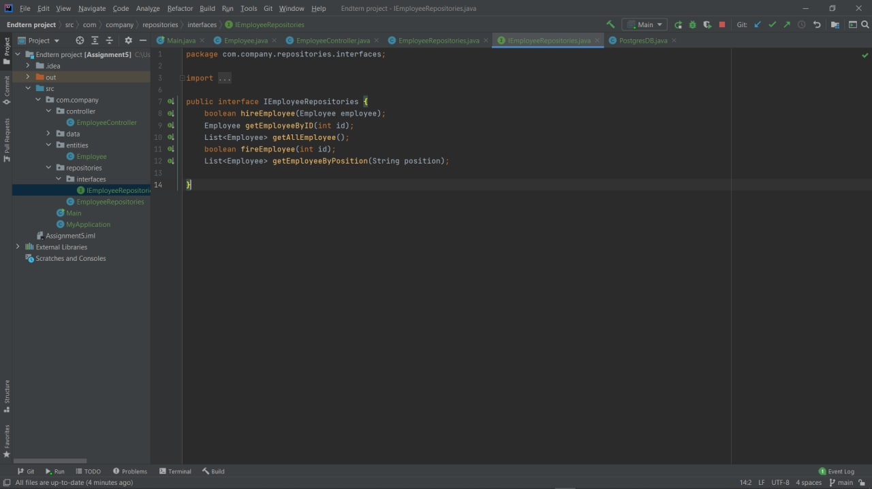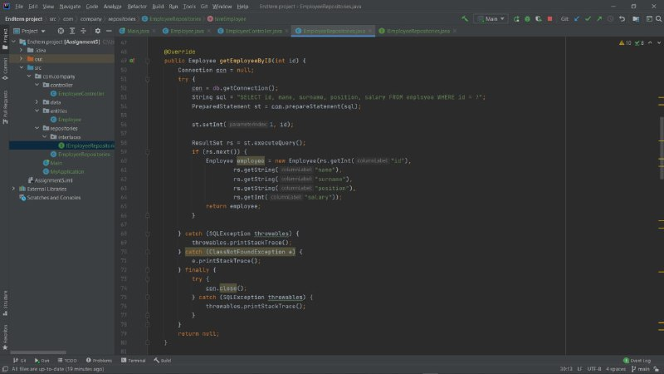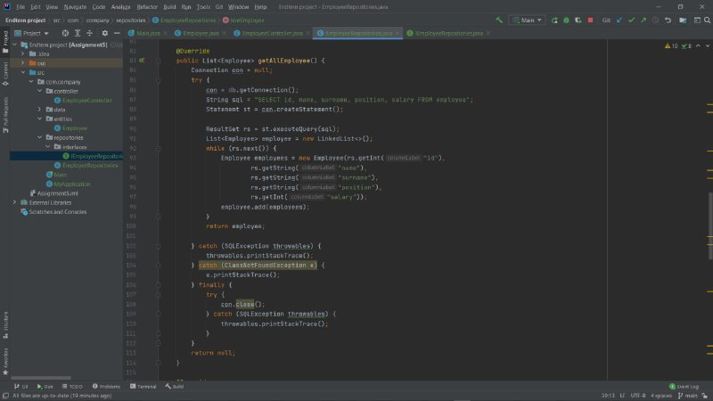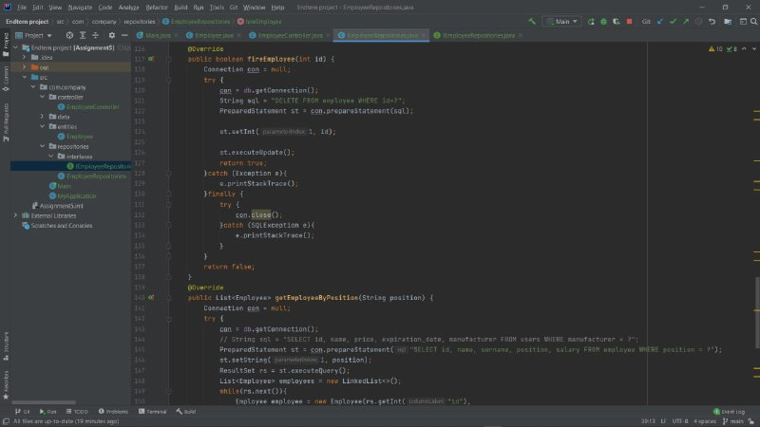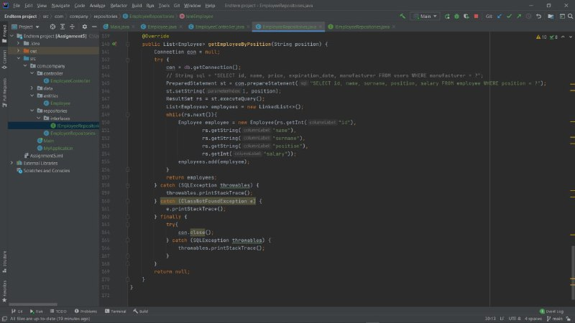

# ER Diagram :

# 

# Акжол Насыр